Software Requirements Specification

for

Trippie

Version 1.0 approved

Prepared by Ravneet Singh, Gaganpreet Singh Grewal and Bojan Lazic

February 9, 2018

Approved Proposal

2018-02-05

***Proposal for the development of Trippie***

Prepared by Gaganpreet Singh Grewal, Ravneet Singh, and Bojan Lazic  
*Computer Engineering Technology Students*

https://github.com/princess97/TripPlanner_V1

**Executive Summary**

As a student in the Computer Engineering Technology program, I will be integrating the knowledge and skills I have learned from our program into this Internet of Things themed capstone project. This proposal requests the approval to build the hardware portion that will connect to a database as well as to a mobile device application. The internet connected hardware will include a custom PCB with the following sensors and actuators Temperature Sensor, Gps Sensor and Stepper Motor. The database will store The database will store the different temperature readings, locations already visited by the user and locations which user wants to visit in future.. The mobile device functionality will include Mobile application will easily analyze the data collected by the sensor and it will also show the temperature of the particular location which user wants to visit. For example, If the temperature will be above or below certain range mobile application will alert the user, not to visit that place. and will be further detailed in the mobile application proposal. I will be collaborating with the following company/department Humber Tech Group, Humber Parts Crib, Prototype Lab. In the winter semester I plan to form a group with the following students, who are also building similar hardware this term and working on the mobile application with me Gaganpreet Grewal(N01139945), Ravneet Singh(N01148757) and Bojan Lezic(N01109108). The hardware will be completed in CENG 317 Hardware Production Techniques independently and the application will be completed in CENG 319 Software Project. These will be integrated together in the subsequent term in CENG 355 Computer Systems Project as a member of a 2 or 3 student group.

**Background**

The problem solved by this project is Most of the people in this world like to travel different places. Sometimes they visit a place which is totally unknown to them, so they need a guide who helps them to explore that place. In return, they have to pay the guide. This increases the buget of the person.. A bit of background about this topic is In order to save money we are working on a project which will help people to explore different places in the world easily and free of cost. Gaganpreet Singh is working on a temperature sensor which will give the reading of temperature of the environment. Bojan Lezic is working on a stepper motor which will be attached with a plastic shelter to protect the delicate hardware of the project. Since this machine is going to be at many different places, the GPS sensor will come in handy to distinguish where each raspberry pi will be located. Ravneet Singh is working on the GPS sensor..

Existing products on the market include [1]. I have searched for prior art via Humber’s IEEE subscription selecting “My Subscribed Content”[2] and have found and read [3] which provides insight into similar efforts.

In the Computer Engineering Technology program we have learned about the following topics from the respective relevant courses:

* Java Docs from CENG 212 Programming Techniques In Java,
* Construction of circuits from CENG 215 Digital And Interfacing Systems,
* Rapid application development and Gantt charts from CENG 216 Intro to Software Engineering,
* Micro computing from CENG 252 Embedded Systems,
* SQL from CENG 254 Database With Java,
* Web access of databases from CENG 256 Internet Scripting; and,
* Wireless protocols such as 802.11 from TECH152 Telecom Networks.

This knowledge and skill set will enable me to build the subsystems and integrate them together as my capstone project.

**Methodology**

This proposal is assigned in the first week of class and is due at the beginning of class in the second week of the fall semester. My coursework will focus on the first two of the 3 phases of this project:  
 Phase 1 Hardware build.  
 Phase 2 System integration.  
 Phase 3 Demonstration to future employers.

*Phase 1 Hardware build*

The hardware build will be completed in the fall term. It will fit within the CENG Project maximum dimensions of 12 13/16" x 6" x 2 7/8" (32.5cm x 15.25cm x 7.25cm) which represents the space below the tray in the parts kit. The highest AC voltage that will be used is 16Vrms from a wall adaptor from which +/- 15V or as high as 45 VDC can be obtained. Maximum power consumption will be 20 Watts.

*Phase 2 System integration*

The system integration will be completed in the fall term.

*Phase 3 Demonstration to future employers*

This project will showcase the knowledge and skills that I have learned to potential employers.

The brief description below provides rough effort and non-labour estimates respectively for each phase. A Gantt chart will be added by week 3 to provide more project schedule details and a more complete budget will be added by week 4. It is important to start tasks as soon as possible to be able to meet deadlines.

Raspberry Pi 3 starter kit, Temprature Sensor(DS18B20), GPS sensor, Stepper Motor, Jumper wires(Male - Female, Female - Female, Male - Male)

**Concluding remarks**

This proposal presents a plan for providing an IoT solution for This is an opportunity for us to integrate many things to create a collaborative project which will help users to plan and visit the different places in the world without the help of any guide and in bonus it will tell the temperature of that place which user wants to visit. This will reduce the budget of the user and save lots of time.. This is an opportunity to integrate the knowledge and skills developed in our program to create a collaborative IoT capstone project demonstrating my ability to learn how to support projects such as the initiative described by [3]. I request approval of this project.

**References**

[1] N/A

[2] Institute of Electrical and Electronics Engineers. (2015, August 28). IEEE Xplore Digital Library [Online]. Available: https://ieeexplore.ieee.org/search/advsearch.jsp

[3] N/A

Executive summary

The following technical report will be on the software requirements for the *TripPi*. This device is a multi-sensor which is stationary at a set location, which works with our app TripPlanners. The report will cover the requirements for the device as well as the app, and will go over the specifications while providing diagrams for the application. This report is significant as it provides insight on all the needs for the project.

Table of Contents

Table of Contents iv

Revision History v

1. Introduction 1

1.1 Purpose 1

1.2 Document Conventions 1

1.3 Intended Audience and Reading Suggestions 1

1.4 Product Scope **Error! Bookmark not defined.**

1.5 References 1

2. Overall Description 1

2.1 Product Perspective 1

2.2 Product Functions 2

2.3 User Classes and Characteristics **Error! Bookmark not defined.**

2.4 Operating Environment 2

2.5 Design and Implementation Constraints **Error! Bookmark not defined.**

2.6 User Documentation 3

3. External Interface Requirements 3

3.1 User Interfaces 3

3.2 Hardware Interfaces **Error! Bookmark not defined.**

3.3 Software Interfaces **Error! Bookmark not defined.**

3.4 Communications Interfaces **Error! Bookmark not defined.**

4. System Features Error! Bookmark not defined.

4.1 System Feature 1 **Error! Bookmark not defined.**

4.2 System Feature 2 (and so on) **Error! Bookmark not defined.**

5. Other Nonfunctional Requirements Error! Bookmark not defined.

5.1 Performance Requirements **Error! Bookmark not defined.**

5.2 Safety Requirements **Error! Bookmark not defined.**

5.3 Security Requirements **Error! Bookmark not defined.**

5.4 Software Quality Attributes **Error! Bookmark not defined.**

5.5 Business Rules **Error! Bookmark not defined.**

6. Other Requirements Error! Bookmark not defined.

Appendix A: Glossary 4

Appendix B: Analysis Models 4

Appendix C: To Be Determined List 4

Revision History

|  |  |  |  |
| --- | --- | --- | --- |
| **Name** | **Date** | **Reason For Changes** | **Version** |
|  |  |  |  |
|  |  |  |  |

# Introduction

## Purpose

The purpose of our project is to work as a personal travel guide. Our android app will work anywhere in the world. We have used google places APIs to accomplish this. We will upload co-ordinates and temperature of a particular location and user can decide whether or not to visit that place based on the temperature. Our app will alert the user if temperature is below or above certain degree Celsius.

## Document Conventions

This part will be updated when we move forward with the document. <Describe any standards or typographical conventions that were followed when writing this SRS, such as fonts or highlighting that have special significance. For example, state whether priorities for higher-level requirements are assumed to be inherited by detailed requirements, or whether every requirement statement is to have its own priority.>

## Intended Audience and Reading Suggestions

The intended audience for this SRS document is our mentor Professor Kristian Medri and our team of three would like to improve this project in the future. This document can also be used as a guide by future users of the app and even other developers that might want to contribute. Since, this software is open source.

## References

References will be added in the future with keeping uniformity in mind. All references will be in APA format.

<List any other documents or Web addresses to which this SRS refers. These may include user interface style guides, contracts, standards, system requirements specifications, use case documents, or a vision and scope document. Provide enough information so that the reader could access a copy of each reference, including title, author, version number, date, and source or location.>

# Overall Description

## Product Perspective

The purpose of our device is to provide a GPS coordinates, as well as a temperature in an area where the device is set to read from. The device has the ability to protect itself from harsh environments using a timed stepper motor connected to a small trapdoor. This device is meant to provide a reliable, native reading on the characteristics for the location which the user chooses.

## Product Functions

Both the device and application need an internet connection to function, and will connect to an SQL database hosted on hostmonster. While our device is connected to a network, it will be able to do the following:

* Read the temperature at its location, and send it to the server so the TripPlanner app can read it
* Read the coordinates at its location, and send it to the server so the TripPlanner app can read it
* Close and open its own trapdoor based on a 5 minute timer to read the temperature and protect itself from harsh temperatures

## Operating Environment

The device will use a 5V bipolar stepper motor, Raspberry Pi 3, active internet connection to send the location and temperature readings to the server, temperature sensor and a GPS sensor.

For the mobile app, the user needs to have a minimum SDK version 21 and an active internet connection.

## User Documentation

The user documentation will be available on the TripPlanners official website. This documentation will come with instructions on how to use the app. The hardware will not have any documentation as the user will not be using the device.

# External Interface Requirements

## User Interfaces

If the user is already registered in our app then the first page which to be opened will be sign in page and it will allow our user to sign in into the app. The first time users of our app will have to sign up. When the user sign up then the app will redirect the user to a page which is called as a bucket list in which user add different places according to his plan to visit. After signing in to the app user is able to see their bucket list in which they can add different places which they want to visit in future. This page will be linked with the firebase database and it will show the readings of the temperature at different places which user wants to visit.

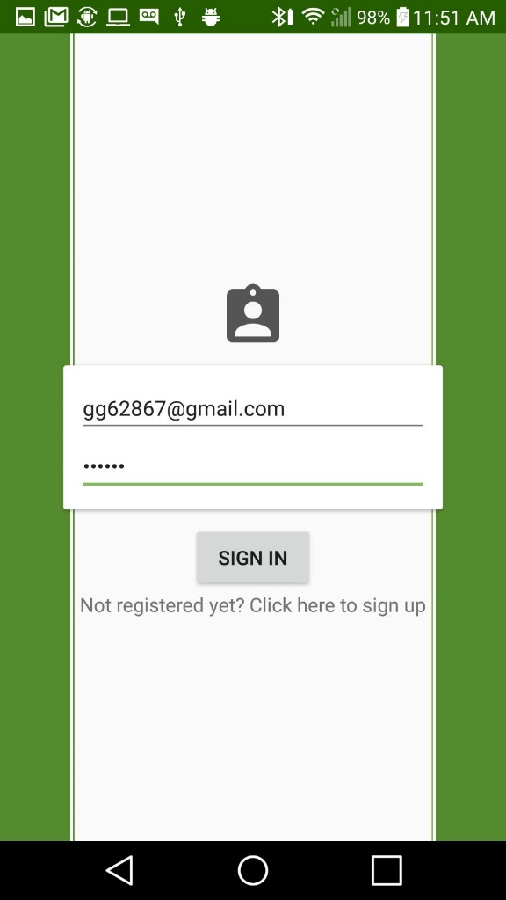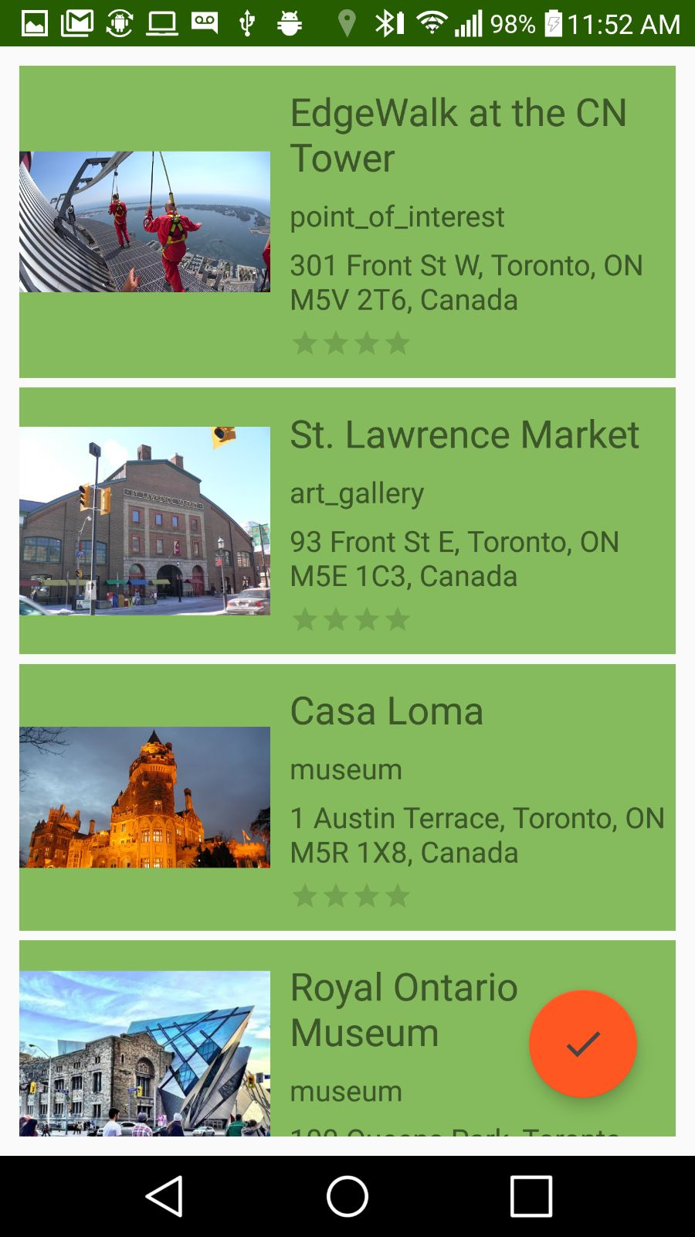

# Conclusion and Recommendations

This requirements document presents a plan for providing an IoT solution for This is an opportunity for us to integrate many things to create a collaborative project which will help users to plan and visit the different places in the world without the help of any guide and in bonus it will tell the temperature of that place which user wants to visit. This will reduce the budget of the user and save lots of time. This is an opportunity to integrate the knowledge and skills developed in our program to create a collaborative IoT capstone project demonstrating my ability to learn how to support projects.

Appendix A: Glossary

<Define all the terms necessary to properly interpret the SRS, including acronyms and abbreviations. You may wish to build a separate glossary that spans multiple projects or the entire organization, and just include terms specific to a single project in each SRS.>

Appendix B: Analysis Models

<Optionally, include any pertinent analysis models, such as data flow diagrams, class diagrams, state-transition diagrams, or entity-relationship diagrams.>

Appendix C: To Be Determined List

<Collect a numbered list of the TBD (to be determined) references that remain in the SRS so they can be tracked to closure.>